Use-Case Realization Report (Design)
Delete Outline

Issue <1.0>
Revision History
Date | Issue | Description | Author
29/11/09 | 1.0 | Initial Version | Rajendran Kumaraguru

Table of Contents
1. Brief Description 4
2. Flow of Events 4
2.1 Standard Flow 4
2.2 Exception Flow 4
3. Interaction Diagrams 5
3.1 Sequence Diagram for Delete Outline 5
4. Participating Objects 5
5. Class Diagrams 6
6. Derived Requirements 6

Use-Case Realization Report (Design)
Delete Outline

Brief Description
Upon successful login of portal admin, the portal admin will be able to perform deletion operation of any outline which is already created. If there is no outline exist the respective error message will be displayed to the portal admin.

Flow of Events

Standard Flow
- Portal Admin login into the system.
- Portal admin clicks btnDelete_Click()
- Validate the fields before performing the deletion operation.
- Delete the outline
- Upon successful deletion then show the message to portal admin.

Exception Flow
  - If there is any validation error message then error message will be thrown to portal admin.
2. If there is no outline exist then respective message will be thrown to portal admin.

Interaction Diagrams

Sequence Diagram for Delete Outline
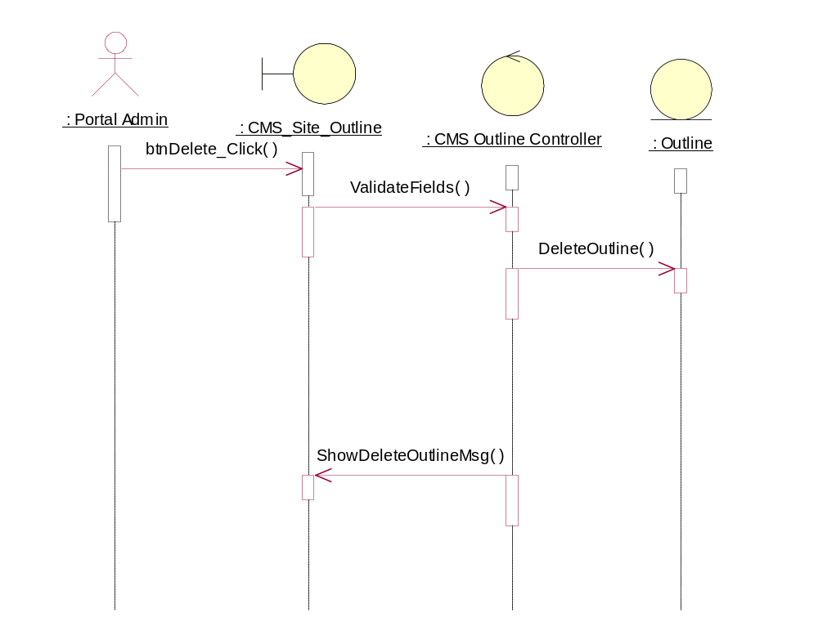

Participating Objects
: CMS Outline Controller

: CMS_Site_Outline

: Outline

: Portal Admin

Class Diagrams
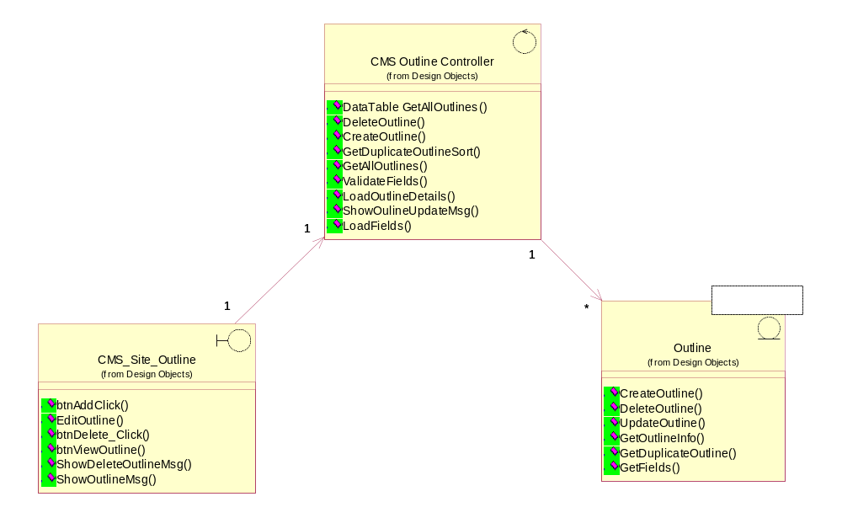

Derived Requirements
[enter the derived requirements here]

